FORM VALIDATION HTML

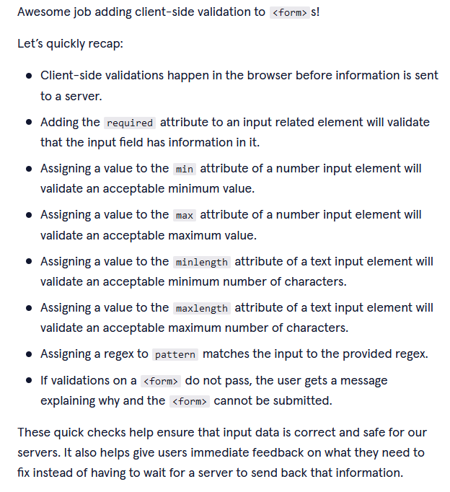

ACESSiBILITY USING ARIA ROLES AND PROPERTIES

